10 February 2025

Beehive Centre, Coldham Lane, Cambridge, CB1 3ET (LPA REF: 23/03204/OUT) – Daylight and Sunlight

In respect of the above application I have reviewed a copy of the correspondence, dated 31 January 2025, from Mr Toby Williams. Mr Williams’ letter sets out Cambridge planning officer’s view that the daylight and sunlight effects of the proposal cannot be supported. I have also considered the January 2025 independent review report commissioned by the LPA and undertaken by Ian Dias of Schroeders Begg LLP.

In my view Cambridge officers have made a clear and fundamental error in their appraisal of the amenity effects of the scheme and the acceptability of such effects. In respect of daylight, sunlight and shading they have failed to properly consider the relevant technical framework as well as appeal and legal precedent relating to the application of the appropriate BRE guideline document.

In particular, the appraisal of significance and acceptability of harm should have been approached as a two-stage process (see, amongst others, the judgment in Rainbird v LBTH, March 2018). Establishing an impact outside of the BRE targets is only the first part of this test. Stage 2 requires a detailed appraisal of the acceptability of that harm. In answering second question specific regard should be given to contextual
considerations as well as the wider planning balance.
This requirement for flexibility, and a two-stage approach, is acknowledged in the report prepared by the Council’s own expert (see para 2.2 - 2.8 of the January 2025 Schroeders Begg review). This approach is not however, reflected in officer’s conclusions which seem to apply a purely numerical appraisal of harm.

We have sought, and there may still be opportunity for, a dialogue between myself and Cambridge’s appointed expert on the correct approach to harm and acceptability. Indeed, a number of actions were agreed between myself and Mr Dias in a meeting on the morning of 31 January 2025. These actions were intended to assist in assessing the context of impacts, however the additional information / discussion could
not be progressed prior to Mr Williams’ letter received later the same afternoon.
Examples of the many areas where officers have not considered the context of the amenity effects include an emphasis on shading to garden at 38 Silverwood Close. The garden contains a number of mature trees which already significantly overshadow the space and it is debateable whether any adverse effects would be perceived by the residents.
In respect of daylight levels there is a focus on harm to specific windows rather than considering the effect to an entire room or property. This includes examples such as 39 Silverwood Close, where individual
windows in an extension are affected but the room benefits from other windows, including rooflights, and will maintain very good amenity.
For sunlight levels there is an incorrect weight placed on low-angle winter sunlight with limited, if any, consideration of the annual sunlight position. This overall annual sunlight position remains high for specific windows identified as a concern such as those between 163 – 201 St Matthews Gardens.
Across the board officers have failed to acknowledge where specific constraints, such as particularly deep rooms or windows that are enclosed upon by projecting extensions, increase the effects to the neighbours. Such features are specifically highlighted in the BRE document as increasing sensitivity and requiring a flexible approach to the application of the targets. There is also no consideration of the context of the proposals despite the council’s own expert acknowledging, at para 1.4 of their report, that effects beyond the BRE targets are to be anticipated if the scheme is to deliver ‘meaningful redevelopment’. The images below provide some illustration of areas of concern raised by officers where the context of the effects is a material consideration:
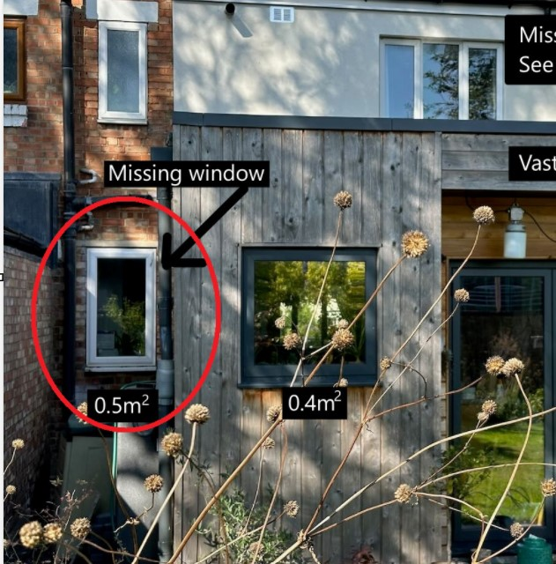
Figure 1: Constrained window at 39 Silverwood Close recessed to neighbouring extension
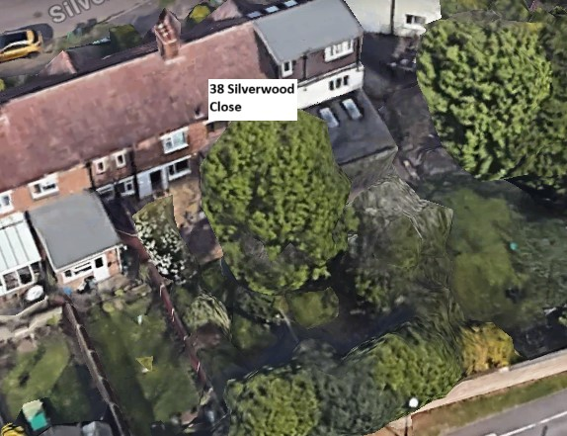
Figure 2: Garden of 38 Silverwood Close with mature trees contributing to shading
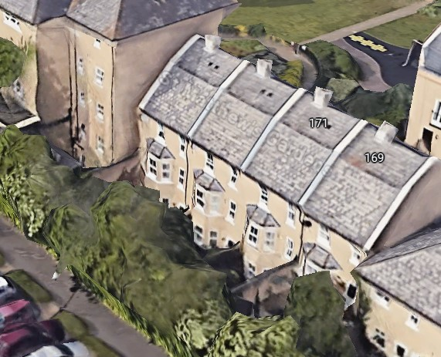
Figure 3: Lower ground floor windows at 169-175 St Matthew’s Gardens in
constrained position and affected by existing trees

I am of the belief that a correct and thorough application of the guidance would lead officers to a different conclusion on acceptability. In my view this applies to both the parameter scheme as well as the illustrative masterplan. If officers were to conclude that only effects of the level caused by the illustrative scheme would be acceptable then I consider that an appropriate condition could be drafted to deliver certainty as to the control of such effects.
Jonathan Lonergan
Director
For and on behalf of eb7 Limited

